Title or Task: | Creating effective presentations
Description: | Demonstrates how to use colours
Files Required | Power Point or Word
Suitable for Classes: | All classes
Area: | Technology & Enterprise
Teacher: | Mr Peter Faulks
Timeline | 1 lesson

Date Due:

Task Brief:
Outcomes: | Students appreciate style and composition

Items highlighted in yellow are tasks for you to complete
Items in Blue italics are help tips

Lesson 138

Creating effective presentations (for Power Points)
When designing and creating presentations of any sort, it is important to think carefully about the styles, colours and layout of the presentation. What did you really think of the sample presentation? Honestly?
The first rule of presentations is that they need to be readable. If your message cannot be read, then the presentation is worthless however if your presentation is too bland, people will not want to read your information. You need to find a happy medium somewhere in the middle.
Use the checklist below to help you ensure your presentation follows good design principles.

Good Design | Poor Design
Consistent colours used on each slide or page | Too much variation in the backgrounds
A select choice of colours used | Too many colours
Colours not too bright | Background or text colours too bright
High contrast in the colours | Low contrast into colours
Colours selected which are suitable for users with partial sight and colour deficiencies | Inappropriate colour selection eg Red/Green See link below
Layout is simplistic | Too many effects – too much going on and can be distracting
No more than 6 points per slide | Too much information on each slide
Large font size used (min 28pts) | Font too small to be read easily
Easily readable font used | Font too difficult to read

Take a look at About Colour.doc and complete the exercise…
Use the Internet to access the following site for further information on selecting suitable screen colour combinations.How does impaired vision affect color perception?
The visual effectiveness of certain color combinations also depends on the audience. Two colors that contrast sharply to someone with normal vision may be far less distinguishable to someone with a visual disorder. It is important to appreciate that it is the contrast of colors one against another that makes them more or less discernible rather than the individuals color themselves.

Here are three simple rules for making effective color choices:

- Exaggerate lightness differences between foreground and background colors
- Choose dark colors with hues against light colors
- Avoid contrasting hues from adjacent parts of the hue circle, especially if the colors do not contrast sharply in lightness.
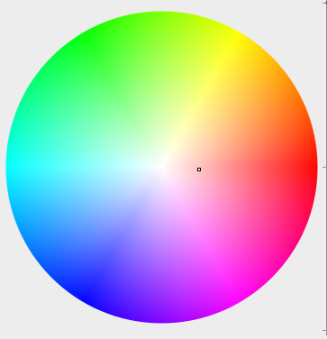

1. Exaggerate lightness differences between foreground and background colors, and avoid using colors of similar lightness adjacent to one another, even if they differ in saturation or hue.

Sample Effective | Make Your own
Sample Not Effective | Make Your own

Use the table above to make your own use Table Toolbar to Fill the table cell and Drawing Toolbar to insert and colour a shape
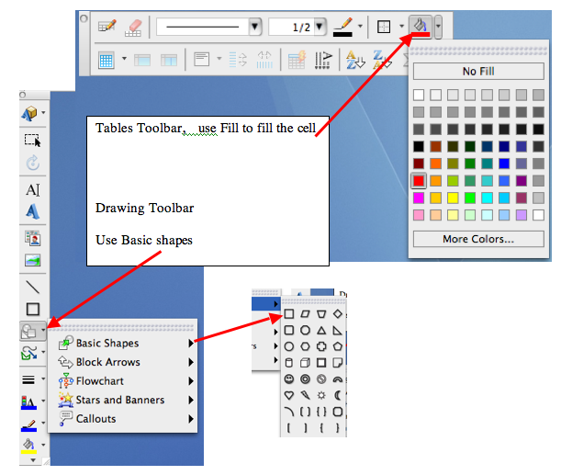

Don't assume that the lightness you perceive will be the same as the lightness perceived by people with color deficits. You can generally assume that they will see less contrast between colors than you will. If you lighten the light colors and darken the dark colors in your design, you will increase its visual impact.
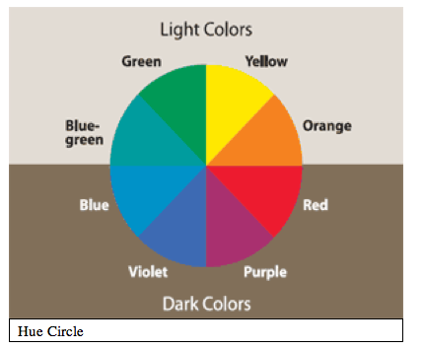

2. Choose dark colors with hues from the bottom half of this hue circle against light colors from the top half of the circle. Avoid contrasting light colors from the bottom half against dark colors from the top half. The orientation of this hue circle was chosen to illustrate this point.

Sample Effective | Make Your own
Sample Not Effective | Make Your own

On screen, the lightness values of colors in the bottom half of the hue circle tend to be reduced.
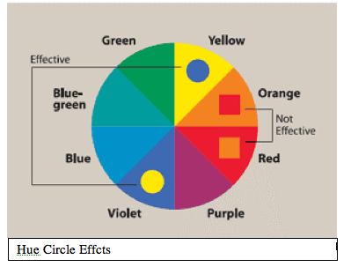

3. Avoid contrasting hues from adjacent parts of the hue circle, especially if the colors do not contrast sharply in lightness.
Sample Effective | Make Your own
Sample Not Effective | Make Your own

On screen (in partial light) make it difficult to discriminate between colors of similar hue.

Hue, Lightness and Saturation
The three perceptual attributes of color that can be envisioned as a solid.
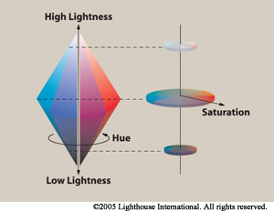

Hue varies around the solid; lightness varies from top to bottom, and saturation is the distance from the center.
Hue is the perceptual attribute associated with elementary color names.
Hue enables us to identify basic color catagories such as blue, green, yellow, red and purple.

People with normal color vision report that hues follow a natural sequence based on their similarity to one another. On screen, the ability to discriminate between colors on the basis of hue is diminished.
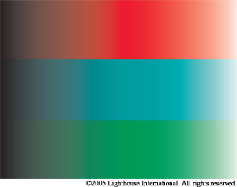

Lightness corresponds to how much light appears to be reflected from a colored surface in relation to nearby surfaces.
Lightness, like hue, is a perceptual attribute that cannot be computed from physical measurements alone. It is the most important attribute in making contrast more effective.
On screen, the ability to discriminate colors on the basis of lightness is reduced.
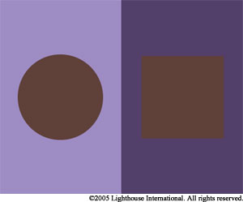
On screen, the left-hand panel might appear like the right-hand panel appears to a person with normal color vision.

On screen the ability to discriminate colors on the basis of all three attributes -- hue, lightness and saturation -- is reduced. Designers can help to compensate for these deficits by making colors differ more dramatically in all three attributes.
Make up a set of colurs that you feel would suit your presentation

Exaggerate lightness differences between foreground and background colors
Choose dark colors with hues against light colors
Avoid contrasting hues from adjacent parts of the hue circle, especially if the colors do not contrast sharply in lightness.

- Exaggerate lightness differences between foreground and background colors
- Choose dark colors with hues against light colors
- Avoid contrasting hues from adjacent parts of the hue circle, especially if the colors do not contrast sharply in lightness.


Need help just ask

